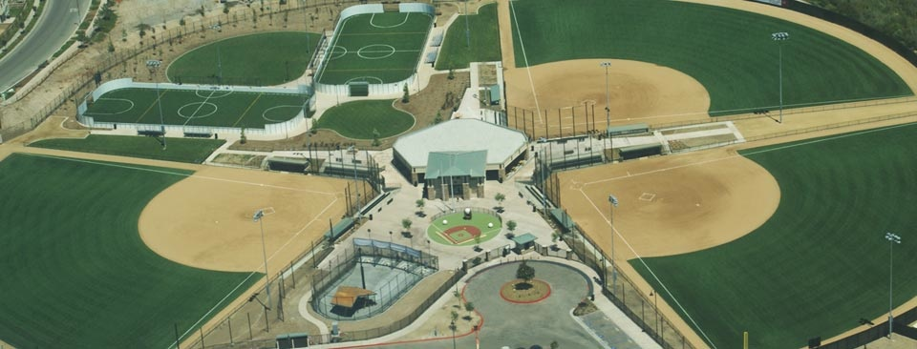

SHOP WITH A COP 2016

***4TH ANNUAL* SOFTBALL TOURNAMENT**

|  |  |  |
| --- | --- | --- |
| PRIZES PRIZES PRIZES  *SILENT AUCTION* | HELP Law Enforcement SUPPORT  Underserved Children | **Men’s Tournament and**  **Co-ed Tournament**  **SIGN UP NOW!** |
| **Date:**  **August 6-7, 2016**  **Team cost: $350/team**  Includes team insurance, umpires, and game balls. Game minimum depends on number of teams registered. There is a $3.00 entrance charge to enter SPORTSPLEX USA for everyone 16 years and older. In return, you receive a token worth $3.00 towards a purchase of any beverage at our Sports pub. | **Location:**  **Sportsplex USA Santee 9951 Riverwalk Drive Santee, CA 92071**  **-3 Turf Fields**  **-Sports Pub (Beer,pizza, etc)**  **-Batting Cages** | **Contact:**  **Senior Probation Officer Michael Keeley**  **619-515-8276**  [michael.keeley@sdcounty.ca.gov](mailto:michael.keeley@sdcounty.ca.gov)  **All donations are gratefully accepted**  **Contact Barbara Avilla @ 619-972-4665**  **We are supported by a 501(c)3 non-profit association.** |
| ***WHAT IS SHOP WITH A COP ALL ABOUT?***  **Each year, “Shop with a Cop” provides a joyful holiday for over 300 underserved children with a morning of shopping at Target with their law enforcement partner. Each child is provided with a $150 Target gift card to spend on themselves and their family.** | <http://www.shopwithacopsandiego.com>  <https://www.facebook.com/sdshopwithacop> | ***THE 2016 EVENT IS SPONSORED BY LAW ENFORCEMENT***  ***AND*** [***SPORTSPLEXUSA.COM***](http://www.sportsplexusa.com) |